 Updated on Oct 29, 2021

supremacy of intelligence logistic, From beggining to end of righteous path productivity and mechanology manifests a system consisting of 100,000 plus software components and mechanicle componentry to refflect on the intuitive conciousness from the species which manifested that polynomer stratedgy/methodology to implicate reflect on the driven impetus for their social sciences of life anthropology, quantified vision for creation ergronomic infrastructure are to be implied to reflect on the geneomic covenant unified established probable, habitual connectivity between them and their roles in of the circular belonging, identity,and social affairs. which defined and enabled of the 'quantified expansion from intrinsic and intuitive conciousness dicipline on a linear anthropologic evolution curriculum manifest/salvation of anatomic self-sustainance 'initiative to create , build belong interact with the teachings of work chronicles/chronology of world hand in hand with i.p of aligned human to intercept covernant free signals from the prescribed i.p crossroads of uninhibited covenant world message of astrological-countanance assigned from specified tradjectory's in prophecy manifested day to day function, productivity, operation .location 'manifests of programed evolution 'occipital' initiatives,agricultural-civil governace, civil service enterprise head quarters, 'urban/rural. Our compay whishes to translate and incorporate epic assignment of life through interpretation of unified world dissedent geneology. from the temperol reasources of intuitive lifeform conciousness, methodology and developedment of social-affairs. 'compliance theological government of crewation righteousness. anthropology 'circular life envisionmet concept, to the logical reformed governance 'vertical tradjectory' Jurisprudence "new city" reformed creation righteousness in all fields of life endeavors.

from this establishment of data characterization for the choice of lesdership grandeur to coincide with orders from project covenant instruction and conquest 'extreme' explicint dimensional description as a portrait of equal proportions in the diochamy of the creation life form anatomy where righteousness trend of the enterprise covenant were to be intrinsically identified and available for assesment to the co-ordinates bio scan of extra terrestrial ect. to the world schema and prodigy of a "new" world enterprise trend. psuedoscience-apfredesiac to recognize trend gifted inheritance of life impetus of architecrture anthropic manuscripts of man rituals of creation biological autheticity and geographic sacred geometry and astrological covenant/countanace , are our archeological conection to the methods of ancestrial earth and mankind of the Quram connection which is most popular and practical to the organology of variable aspect envisioned to destiny of the ;family[' good to mankind , 'quantified purpose of life and stock of idustry reasources are an understanding of to the intelligence/orientation of life, great gift and provisions reganding concern for plotter of expasion to plannar activity's for enterprise poll for theological subsistence productivity of global empire to translate quram energies through aquaduct in the providence of the "monad global empire" "nebuchadnezzar" world prodigy. "glory" to world intrinsic lesson, tuteledge of education, righteousnes the'alfa-omega 'creations intrinsic, cononical, human moral creation restoration system. explicint creation enterprise architecture, of 'anthropology concept'.

Ingredients coveted cyber information decrypts falsified attempts on covenant protocols devised through intrisic investigations and reasearch producing. multi generation vertical multi geneology synchronized chronicle and chronological events to observe varification for translator linguistic 'carer alignment 'theological 'truth' results prevading infrastructure provision for classified/naturalized entitlement of gifted talent skillset in social-affairs marketing of compiled benifactor of provision. encouragement of Anthropology concept devise and employ to this "epoc"life field of endeavors and

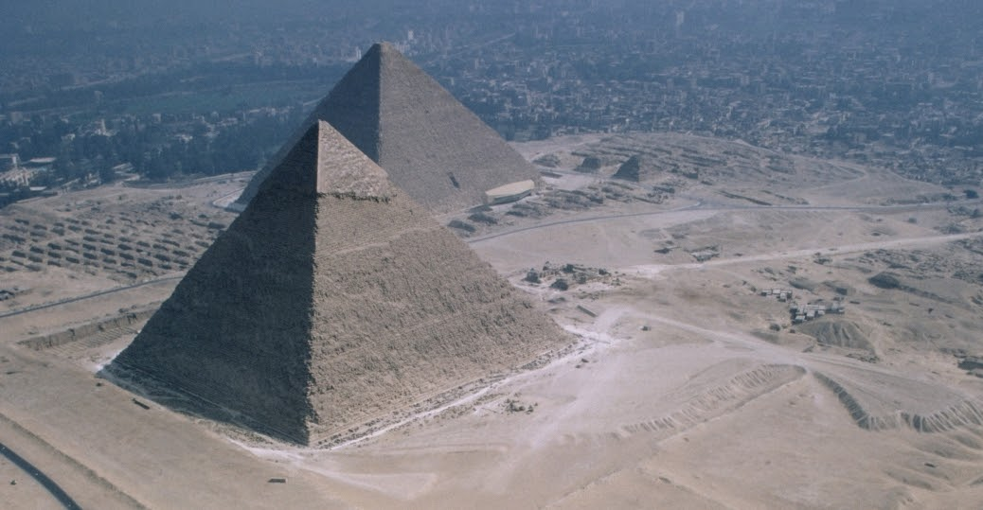**Armeggedon of human supremacy**

These are the facts that are deployment to the ideologys of millenia expansion and evolution constant  factors of life virtual-reality.

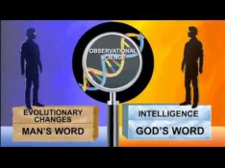

*1 - Civilization New world creation of man's world intelligence, god's work /emotions toward ecologically productive  evolutionary outcomes, 'in themes of civilization ettiquette: religeon, governance, economics,social-science, patriotism,  curricular regiemen .*

*The strength of the individual and his universe- The strength of all population and their universe. Contracting the law of the  world through unison of ethical methodology to produce culture and to develop materialism through the logistics cultural arts; life  methodology { value of transendential energy} "the gospel" translated in the ethics manifestation of human reasource provide s  control of the material boarders that confine the moral disposition in probable ecologic potencial of the '5 horizons 'capability of  successsion to lifes destiny ,manifestation {only as strong as it's army} to life hieroglyphic life image, quality's of known  environmental inheritance in world architecture of "life choice" cononicle gospel and reality of world. The exercises of “life  weaponry” the provisions of success, 'the serrenity of salvation /manifest . ‘instruments of life variable factor and logistic co efficients from this we define the life constructs, 'the purpose of 'human ettiquette' from reading, analysis,diversity, appraisal of  life capital {essentials and nessesitys} life from the code of conduct, natural intuition or the ettiquette in human chronicl e brotherhood of gospel define a choice in the level of committment ‘spared to obtain comprehension of lifes survival-exsistence, ‘world precision and  personelle objectives’ ‘that fit and that fullfill mandate of the worlds provisional asset for any geometric stimulus {life  vocations}} of world efficiency in compliance objectives to the world protocols {natural science}: competance stage 1*

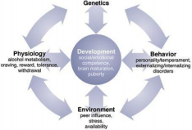

*2 -* ***Through the evolutions 'intelletual guidance of creation logistic theorem, mechanology 'resides the "UNICORN " of  'modern sociology' tradition, binding to the enterprise interface of human first-principals technology, dual ontological  interactive biography of five horizons 'unifed creation stewardship engineering'.***

**Introduction Connection to life' of evolutions, new world intelligence matrix, stewardship 'life  progression. Creation 'tuteledge, social ethics, religeous philosiphy, creation inheritance message,  alfa-omega 'Five gospels 'creation natural reasource of'occipital stewardship'.**

Set up your project. Provide some context and color. What are you doing?

Research and Preparation 'for innovation "The Centre of gravity"  {explicint} alfa-omega 'define the terms of creation enterprise  architecture.

**Explain how you prepared**

**A layout on transparent canvas of creation reflecting 'the complex world from diversive variable factors of creation mystic survival theosiphy {subsistence} 'inheritant through the adaptive 'occipital'  lifeform genes of social interactive creation algorithm of the millenial operations purpose and  function ‘dedication to the complete life process,developedment and growth applications in the mystic evolution chronicles, 'the theosiphic' "enterprise-architecture" of creation and life mechanology of  man. In the demographic evolution of creations new millenia. An ideology facillitating 'creation mystic  authentication' of orthodox or logical generic process of revolution, 'binding unified world covenant  to creation orthodx protocols' so that superior anatomic connection to experience of creation 'statutory'  binary are envisioned aesthetics of creation manuscripts/creator. profficient life  censuses/stewardship purpose .**

Redemption of stewardship

Content Marketing : carried by endeavors of creations’ life form and lifeform geneology of vocational  world,animal,man hereditary naturally descriptive gene characteristics. Are the psycological  virtual/reality arranged by the creation psuedoscience ‘earth’s mystic gene life aphredesiac

(hypothesis) metaphore of world infrastructures social anthropological manuscript , ‘ the geneology of  world survival-exsistence promise for exsistencial subsistence plan of life{surrrenity}; culinary arts ,stewardship  engineering, household engineering , gene architecture of diversity’infrastructure, tuteledge and  hierarchy of “family” 'revolution of world manifestation.

The exsistencial subsistence logistics/plan of Christian Global world Enterprise; creation operates on reverse  principals of the countenance binary (Iso) precision of unified productivity, characteristics in creations  collective archive of “forager”vs chronicle subsistence metaphors intel’ of life animate virtual-reality and geographic emancipation of materialism, meteorology .

The both inspire bothe the constructs and mechanology of spiritual creation exsistencial message.

And that the triangulation of world guidance and direction of the holy primate chemistry ‘’archaic  investigation for life course trajectory of creation manuscripts in the divine-liturgy of world hunter gatherer subsistenance organology,’and then methodology that plays tribute in ritual , environmental  conciousness ,purpose , cause , meaning in spiritually mediated duty of abiding to call of greater  importance or cause .

generic characteristic potential

gospels dispose of any falsification in the prodigy of ballistic/forensic world characteristic profiles of the  covenant .

environment ,institution ,opportunity of unified productive ‘world fundemental foundation, of relative  lifeform brand and trends ‘immunized vocational personelle of diversity.

**LOGISTIC TRANSLATIONS IN GOD TO THE EVOLUTIONARY OUTCOMES OF MAN CIVILIZATION**

And binded are Logistics of God to man's evolutionary intelligence . So the Ontological guidance - direction for survival-exsistence , 'evolving into world prodigy of the intellectual dimensions in field of  covenant 'occipital' mechanology, 'where logistic tuteledge of creation enterprise defines creation world  architecture through the purpose of creations logistic occipital education selfsustainance of world  family, 'subsistence training/curricular 'creation learning through virtual-reality of selfsustainance  survival exsistence focusing on anatomic human intelligence geneology 'function endeavor world/life  ettiquette of environmental "isometric equal and unified committment to the focus of  economic/demographic/industrial civiliation of stewardship governance and evolution programming for  process,developedment and growth of the life vocations curricular governance of world Ontology 'of the  enterprise 'architecture producing .



*3 - Proffesional social infrastructure 'circle of the quality's embraced upon the land in the name of life industry and decendant  /ancestor or bearer of purpose to land of covenant, testament, 'stakeholder will enshure that the cycle of a new world  civilization resistence are born to uphold to the corporate sector from the archaic heroism*

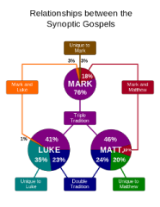

*4 - Relative archaic design graphics in the fine-arts 'establishes this community of the intellectual prophecy in god and inheritant  evolution in man, remake the theosiphic hypothesis for the dynamic world prodigy of guidance tuteledge ,ontology of man's  quest for control of the fraternity codex/ tuteledge that builds the traits/trades of the ergronomic community culture 'the  fundemental empiracle logistics that makes-up for the structural ecological reasource intelligence and diversive emotional  evolution 'analyze synchronization of ecological system risk,of the statutory principals, fundemental cononical tradjectory of  covenant were to take in effect the measurment for scalable reasource efficiency dimension and integrated data incorporation  and implimentation to world industry system technology, 'the subsistence knowledge wisdom of ecological world prodigy/  creation engineering mechanology, a biblical prodigy of creation gospel facts .*

*Leadership ideology*

*To following a decendance power which has interpret defined and left artifact evidence for the aphfredesiac/psuedoscience of  sanity transparent intellectual elements of creation fullfillment fundemental intellectual foundation and exercising authority of  the industrial trend for life endeavor 'way of fullfillment is crucial. By practicing adaptive leadership beyond the authoritative  management of scholar creiteria, {entrepreneurs} risk telling people what they need to hear rather than what they want to hear,  but you can also help your organization, community, or society make progress on its most prressing matters .*

*1}.You know what people value based on their behavior, not based on what they say. 2}.stakeholder could lose if progress is  made. identity, competence, power, reputation, 'for exchange to capture new "innovative" stakeholding principals or  stratedgy's. 3}.*

**

*5 - Stakeholders ,Proffesionals ,Entrepreneurs ; 'Each with a unique genome identifier of character reflecting purposeful  outcomes in the field of creation life endeavors{ettiquette} of human supremacy. Ergronomic infrastructure.of creation  innovative revelation .*

**

*6 - Inspiration for life growth evolution, 'betterment for commongood ,weath,exposure to the hereditary fundemental foundation in genome censuses 'entitlement to serve order in all endeavors of life primary protocol preserve globalworld  survival-exsistence, 'essentials and nessesity's.*

**

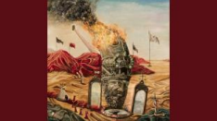

*7 - Buddah ,Missletoe , Jesus ,Gospel word, implied as corporate operations managedment of creations' "enterprise  architecture" dicipline of stewardship apprentis-mentor .To abide the service entity of life work. approachable applications of  linguistic complexity.*

**

*8 - Proffesionals Missions of benifactors*

Revamp Ethos,pathos,logos of creation: New world mystic intel for creation data, the life purpose  function and alternative of life governance ideology. Unified creation anthropologic defined cognitive  learning through logical creation life system facility and tuteledge ‘enables simple primordial experience  and understanding of the life form growth and developedment exsistence/survival experience of life  selfbeing ‘gifts of creation survival doctorine of natures logical and unified ‘lexical orientation of creation  apfredesiac archeived primordial constant of ‘matter time values gravity, longtitude, temporal  cognition interacts creations bare anatomic lifeform essentials/nessesity’s, ‘conciousness for world life  prophecy {gene pool} of censuses binary creation .

Use this section to talk about what preparations were needed for your project. Add content to show  your work. Use text and captions to fill in details. If you've uploaded a video to YouTube, then pull that  in as well.

Text in Sway works like regular text, with a twist. As you type, Sway's design engine generates attractive,  professional-looking styling that blends well with your multimedia content. You can use **Emphasis** or  *Accent*to differentiate how different parts of your text look. Emphasis makes that text stand out  noticeably. Accent makes text stand out in a subtler way, with the same level of visual impact. You can  also add bullets, numbered lists and web hyperlinks.

Add videos,tweets, and other multimedia to make your Sway even better! Transform a set of images or  other pieces of content by selecting them and choosing Group. Then you can make a stack of photos, a  before/after comparison, a slideshow, and more.

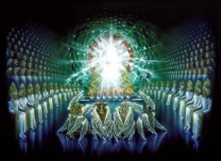



Building It: We want to concieve a product design to influence a trusted  brand from a composite foundation from life source of creations natural,  ecological 'truth of creation

from life source of creations natural, ecological 'truth of creation 'variety, dimension and productivity,  creation geneology a jurisprudence ,subsistence , authenticated mechanology graphic revealing  manuscript, provisions  graphic canvas used for graphic suspended engineering tradition technique to impliment  image/application accomodate ettiquette in developedment of connect to occipital stewardship to  maintain and preserve compliance of creation mechanology of engineering implimentation technology  to tap into the reasources of correctly aligned construction/ building creative survey and stratedgy's  template of correctness in stock and technology in capital assets /reasources protocool.

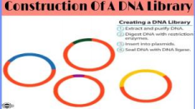

*9 - The dna of the society's first civilization principals to remain endure longevity of world lime, tennents, 'lamentation logistic  revelations in man's ettiquette of diversity and compliance to initiative alignment of enterprise tradjectory.*

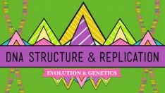

**

*10 - Emotional-Democratic and Intelligence evolution jurisprudence law of social-society civilization policy's we can harness and  utilize the stewardship fundementals principals of elite creation ethic education engineering 'implimenting the protocol of  humanity's simple primary design themes of man.*

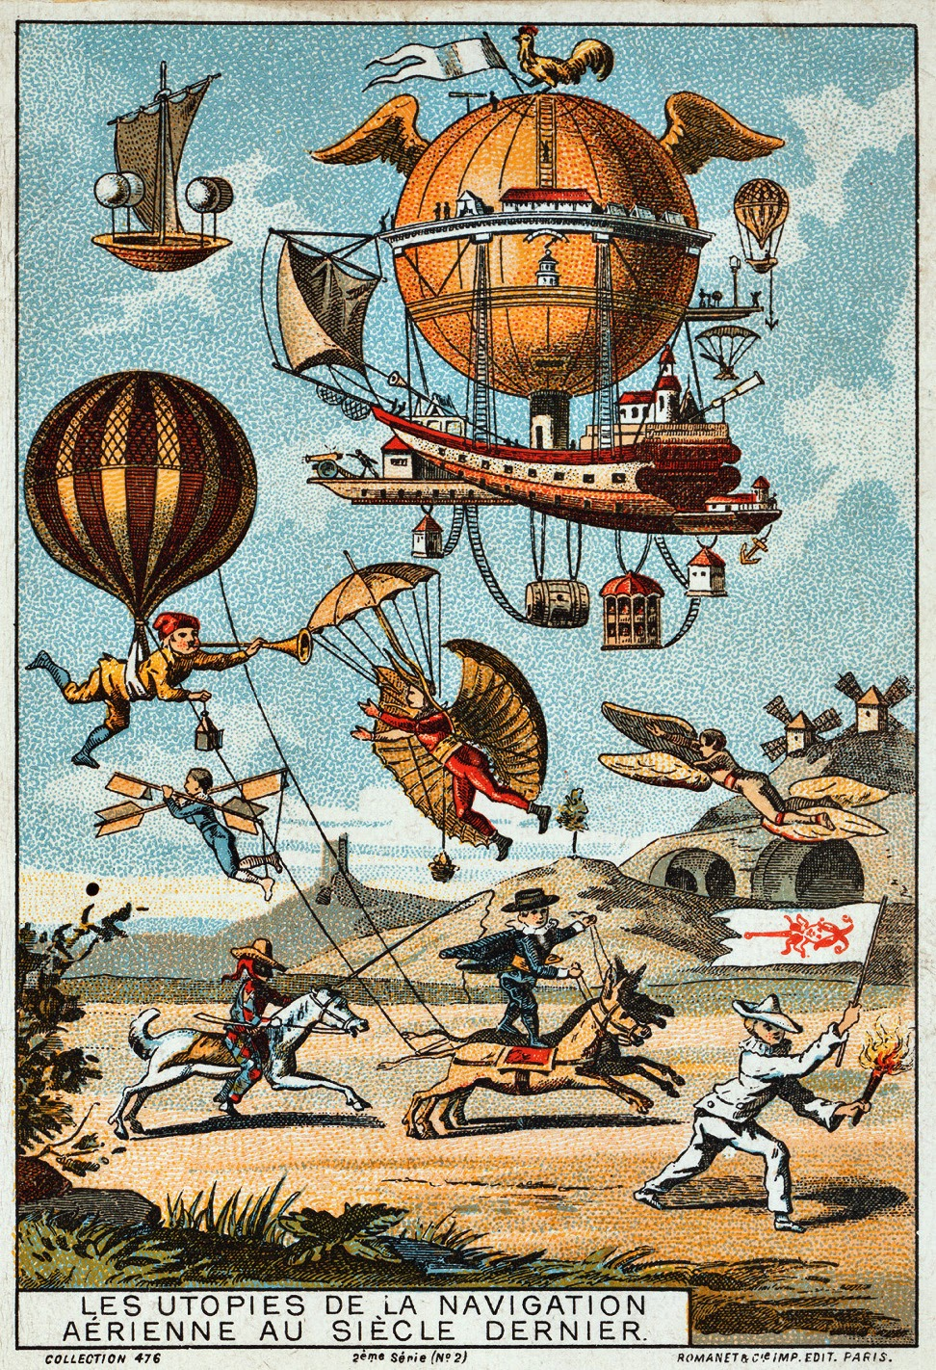

*11 -* ***MODERN ARCHITECTURE***

***Evolution of Human First principals, of the Occipital fundemental-foundation. Providing the intellectual reasources and  facillity's of the life essential needs of survivals democratic subsistence exercises-practices of life nessesitys.  Dicipline,order,methodologic principals of creation architectural revelation.***

**Walk us through step-by-step**

Use this section to walk us through the process of actually building or making your project.

Ontology of life ' The information process of creating an archeive of the human codex or ritualism that  reflects on The growth and developedment stages of the animal / human lifeform organism of world  ontologic evolution/ life mastermind.

**Planning Orthodox stewarship policy's of enterprise's contractual labour . Equality of lifeforms .**

As the stages for an organisms growth and developedment are-implied and are explanation for all  manifestation of life derived through life organisms of creation' the intelligence counter balance of  nature that's implied by the equality of natures interplay of diversity forces a rhetorical apfredesiac of  probable creation interaction developedment principals, 'logistic alignment to the creation occipital  characteristics of meaning and purpose through the generic and hereditary inheritance of  Anthropological concepts parity (the constants of hirogliphic world image/virtual reality/life  materialism)' the world life ideology of world prodigy defines the incentive of the life organism in  compliance to the prodigy implied by the worlds innovative life system conciousness of meaning and  purpose and function.Translating the function of "NEW WORLD" anthropological science and social  ethics l will define the biographic manifest of gospel world prodigy through Anthropological concepts  'through creations manuscripts of life form information/intel to generate the demographic data which  reflects of the 'intellectual' organic life metabolism.

reverted by the innovative ecologys manifested life system receptors of the lifeform censuses, scale the  physical system performance and developedment from orthodox stages inherited by the accountable  generic metabolic binary system methodology of the creation life form (monad evolution)' ethics and  linguistic anthropological constants of the the hirogliphic genesis information. life hypothesis, mystic  tradition, gospel world prodigy '(innovative ecology).

This branch ontology will imply that observation to the codex or ritual performed by adaptive,  interactive 'geographic life organisms will render the conciousness of communication with the principals  embedded generically in individual life organisms evolution and are execute of reconnaissance with  god's world futility 'the life fundamental foundation and cellular nucleotide and knowledge based  forward facing 'orthodox logistics position of the covenant campaign; supports ambition of incentive  with the creator and creations meaning and purpose (lifecycle) by the collectives data mitigation life  information/intel. For multi-purpose implimentation of the enterprise operation,developedment ,

'

A COVENANT

Each individual life species represents of the world methodology magnitude of the fortitude generated  by the lifeforms geographical standards to imply of Anthropologic concepts social unification of destiny's  world prodigy and balance of world gene chemistrys 'aphredesiac constants of world and the universe'.  The ontology of spiritual world biographic scriptures and manuscripts that life evolves through the  revelation of the world at an alternative purpose than the organic life form reflecting in the parity of it's  own self mimage and function of their own characteristic purpose in life Anthropologic .

Concepts architecture is of the image of the world life endeavors and then reflects' in the manifestation  of the world and nature ' the ontology of the world chronicles. Birds in The sky lions of the jungle, fish in  the sea, Man in The domain the life kingdom, paradox of unified world prodigy of ‘covenant’ virtue to man and world 'earth wind and fire and  earth air water fire .

The information input of biological physics zygote catabolism anatomical metabolism represent the  temperol conciousness of the virtual reality is pending the world anthropological materialism theory of  life ontology.

This note will b'e in conjunction with the continued human evolution developedment and growth with  the ontological macro evolution employed on earths adaptive logistics network backbone information  technology of life 'the democracy of the geographic social economic capital, ethics scriptures and  manuscripts and of the world timeframes and renewal of it's moral disposition. The establishment of the  adventis life is the world creation and-innovative prodigy that inhabits creations life dynamic .

Lifes’ industry standard name’ implicates, ‘The reason, purpose and cause for the sequential gene  ‘architecture of many worldly tools of life traits and trades 'life diciplines which are expressed  throughout the dynamic parameters of world direction and guidance, as in like of the father almighty,  tree of life, ergonomics of world geography, social science ,ideology of man, 'all of these worldly traits of  life, all implied To by ‘the sequential generic discipline of life enterprise architect’ (collective  manuscripts). The natural-intuitive establishment of the adventis / genesis fundamental foundation in  creations gospel word, implicates of the representation recognized by the creations natural prodigy of  elements, experiences of the physical variables, spiritual enlightenment via creation through cognitive  survival awareness mutated over the orthodox , fundemental materialism of 'primordial genesis' : light ,  air ,water and land of the holy as touteledge of the salvation and manifest endured by the mystic  Anthropological origin . This has led man to the human resource of his life ideology,Mythology "gods  work" of mystical couciousness and world leadership.

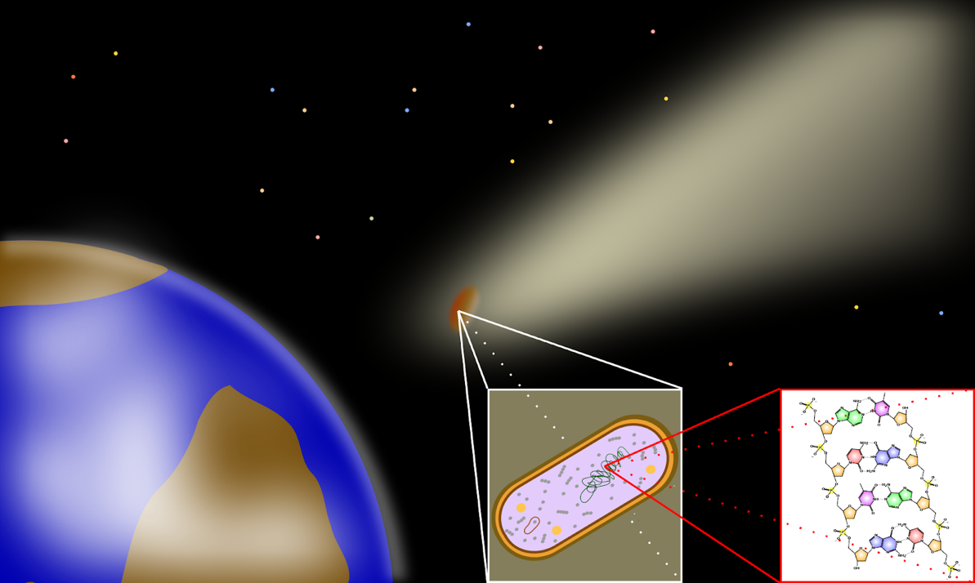

*12 - From "genesis" the eternal fundemental form*

**

*13 - probabilty for democracy of "civilization" ethic society ,*

*14 - artificial intelligence or aphredesiac maintainance of virtual-reality;tree of life , branches of anthropology, new world. {iso}*

*15 - Biblical migration from jerusalem , Forces of industry proffesionals of creations life vocations and mentoring of creations  demographic fields in life endeavors 'reasource of five gospels' traits-trades of the occipital diversive forces, path of life "new  world stewardship selfsustainance program. As civilization Industry technology is leading man to the selfsustaining roles of  empiracle, censuses competance program' enterprise architecture' of corporate industry.*

*16 - In search for new and broader fundemental coherance stratedgy's to enable optimum inspiration of contextual faith .*

*17 - Constitutions fore fathers of man's hieroglyphic fundemental-foundation.*

*18 - Industry Enterprise Architecture:*

*Engineering Technology Establishment of constructions 'schematic of creations logical architectural, 'creations fundemental  science, 'psuedoscience, aphfredesiac natural and authentic orientation of the covenant that can be of reasource to  instrumentation and technology solution of scope/spectrum for integration of simple implimentations of innovations world  apfredesiac, 'ideas planning of the covenant.*

**Step 1**

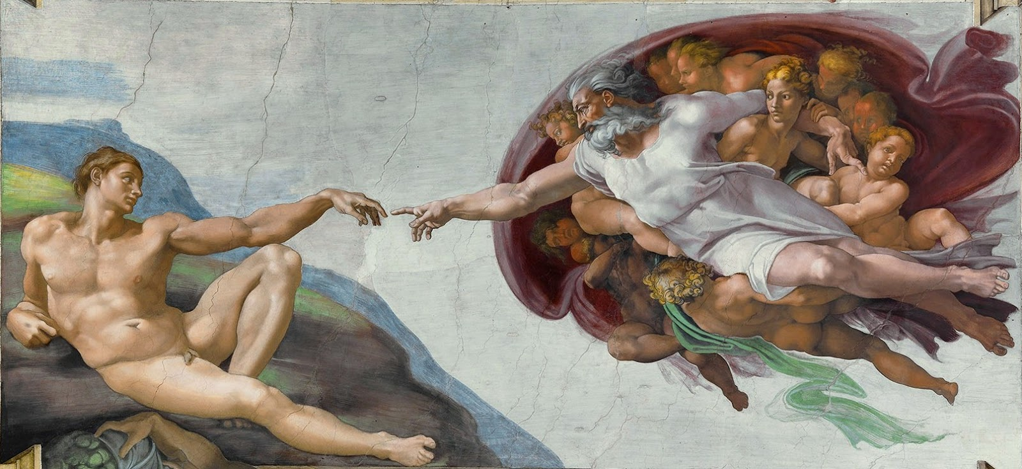

World ergronomic subsistence standards of exsistence/survival ' decryption of the jurisprudence  logistic physics virtue, 'the cognitive disposition of values . "the tree of jurisprudence" 'diag of a  geographic geometrys align perfection out of everyday rutines curricular profficient/efficient  fundemental-foundation processing, developedment, growth of creation conciousness and ip of  methodology.

**Step 2**The Original Anunnaki Bible! Discover the secret library of Sumerian cuneiform tablets kept by the oldest Babylonian mystery school of Mesopotamia and preserving the most ancient writings on the planet. The revised and updated 10th Anniversary Commemorative Edition of the Mardukite underground classic available in paperback for the first time!  
  
The Anunnaki Bible of Mesopotamia... Sumerians... Star-Gates of Babylon... The "Ancient Alien Gods"... Igigi "Watchers" of the Judeo-Christian Old Testament scriptures... Religion, mythology and magic of a long-lost forgotten age... all of it preserved and presented in this much anticipated 10th Anniversary revised and updated infinity edition of the complete Mardukite "Anunnaki Bible."  
  
Joshua Free's "Anunnaki Bible" is quite simply a masterpiece of Mesopotamian magic, spirituality and history, providing a complete collection--a grand symphony of correlated materials--of the most ancient writings on the planet. The oldest Sumerian and Babylonian records reveal detailed accounts of cosmic history in the universe and on earth, the development of human history and descriptions of world order--all of which were used to maintain spiritual and physical control of humanity--proving to be the predecessor and foundation of global scripture-based religious and mystical traditions thereafter. These raw underground materials have shaped the existence of man's beliefs and traditions for thousands of years; right from the heart of the Ancient Near East: Sumer, Babylon and even Egypt!  
  
Nearly a decade since the modern Mardukite inception--and thousands of copies in print--the "Anunnaki Bible" is a revolutionary "New Age" advancement in authentic historical, spiritual and mystical research drawn from a unique unparalleled combination of archaeological findings and esoteric mystical magical traditions. Sumerian, Babylonian, Akkadian, Assyrian, Chaldean, Egyptian, Yezidic, Zoroastrian... and more. The heart and soul of humanity, from the cradle of civilization, is laid out clearly for the "Truth Seeker" to see--in its pure and undefiled state.  
  
A wellsprings of hidden information and historical research, cuneiform tablet transliterations and translations, and mystical and spiritual experimentation may all be found within the leaves of this new anniversary edition of the underground bestselling classic Mardukite "Anunnaki Bible." Newly revised prefaces and tablet introductions guide the "Truth Seeker" through a beautiful presentation of the Ancient Mystery Tradition accessible to anyone with any background. You will discover the original secrets of Hermetic Tradition, the "Books of the Dead" and Underworld Mysteries, the origins of the books of Genesis and Enoch... You will, if you dare, unlock the forgotten and forbidden power of the Anunnaki Babylonian Star-Gates--lore that predates and is a basis of Hebrew Kabbalah mysticism, from which much of the Western Magical Tradition is rooted.  
  
Join thousands of others and take a Self-honest moment in life now, to invest yourself in the path of "true knowledge," where you may find the empowerment and enlightenment of "true experience" - true Gnosis

Definition and 'transformation of lifes fundemental-foundation into direction of the "new flesh" a  graphic image {hieroglyph,codex} to reveal/analyze creation architecture selfsustainance and  chronology of {yin} integral operations purpose, 'to establish foundation in the form of a sequencial,  dualimage prodigy of life actuation, of the metaphore and hypothesis in the truth in finding restoration  and preserverance in the creation theology of the life spirit that drives the initiatives in our reasource  objectives and engineering plan partners.

*19 - Finishing touches of the "Jurisprudence" gold cap of painting detail to seal our home improvement dialogue*

Conclusion

 Biographic anthropology of new world Industrialism -Agriculture-Engineering-Economic capitalism-creative arts inventor. Stewardship alighnment for life linguistic destiny ‘the world ontological alighnment  ‘the destiny of the world global information systems branch anthropology’ the alighnment of civilizations methodology,’the sequencial-generic  tool of (anthropological dicipline)  report ‘natural life system force for mitigated new world testament of Stewardship world censuses .

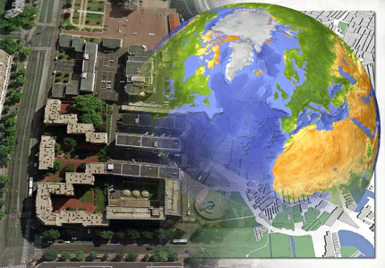

Compliance note -Trust, Will , Sense Conciousness ,censuses

Organic Supremacy - social ethic interface of life law in matrix contribute to the Industrial , Commercial , Domestic societys to implicate the exercises/practices of their cultural preservation with the stewardship of man/spirituality and their ecological world foundation with man and fundemental world .

Mechanology: democratic love - anthropology

Citizen-Proffesional expose their industrial position with societys protocol of world infrastructure ; social public ; social interactive code of beaurocratic conduct in human world infrastructure.

Hiway priority path consumer consumption build complete paradism of image portfolio -biographic manuscript for methodology .

Patent success path cultural Ontology of individual human reasources.

Stewardship via presentation or maintainance of trusted networks, ‘of will to earths creation for explicint providence of human manifestation , mutation to anthropological ettiquette of man ; environment brotherhood - tree of life manuscripts, testament of christ.

Primary protocol of the world life endeavors (hedgestone) network principals of mans neurol legacy compile adaptive symetry with the passive natural biological symetry of the creations information processing ‘ecology’ by unified constant of geographic tennents; anthropic networks, ‘tree of life systems’ nessesity essential that provides precision chronological timing era of analogous api logic interprets natures logical ‘adaptive frameworks,componentry,applications of muscular skeletal/composite frameworks ‘fundemental-foundation’;bio reflexes,variables analysis to translate, interpret robotic programming of analogous a.i machine systems used to connect relative bio programming mechanology and interpret authentic multi-dimensional creation design aspects ‘template’. fundamental foundations  neurtured cultivated perfection for the open  statutory delivery of intel information  on free radical mandate of unified organology

‘Implimentation of 5g ‘Occipital’ networks orchestrated on subsistence  ‘generic priority protocol’ in collective “life endeavors” 5g path of life revelations of man,world,animal.

 Creative arts, ‘ art forms logistic principal of industrial/priority protocol in human reasources ‘infrastructure’  innovative creation  lifeform ideology cognition of life organisms anthropic chronological symetry, biological virtual reality  binary characteristic profiles of life ideology in the covenent of aphredesiac.

Truth of stewardship to architectural image of prodigy (erogronomic capital adapted in ‘ontological connection to world field of lifesystems, logical endeavors: industry/protocol, channel, construction, innovation, technology, social policy {dicipline} life managedment, career managedment {theology exercises/practices}public services:  real estate, law /medical, fundemental-foundation  primary protocol I.T and implimentation/infrastructure ecology) in destiny from survival/ exsistence methodology are evolutions  modified world ecological profficiency via infrastructure of world ecologys ontological manifest of survival-exsistence in parrallel unison with the ontological manifestation of human scripture/manuscripts the methodology/stratedgy of human life ettiquette process developedment and growth and is the synergy of life methodology in unison with creations precision /perfection in productive gospel union.

Harnessing the natural reasources of the worlds capital market places {neurol geographic location for  talisman of knowledge wisdom} in the collective sciences of his collective senses, matching variety and assortment of life ‘the gene identity of the forensic science that interprets the messages of nature methodology  of biological life manifestation  and mechanology of the spiritual identity and presents in world creation. Socialethic sciences of life manifestation -innovative prodigy

The fraternity data wisdom of demographic censuses laws of social standards, ‘advanced world/life initiatives ‘the gene tuteledge of creations socialethics :Mt everest , Supreme court , Constitution of the United States , enroute to genetic forensic ballistic balances in character of lifeforms ecological cause and effect “moral ettiquette of rationale and life principal , destiny , omerta.

Censuses geographic

Censuses via destiny-dynasty and manifestation of demographic censuses data information-intel for world sequencial generic lineage of linguistic unified environmental mandate with the collective revelation of world creative arts/organology : mechanology -methodology social ethic of the creations mythologic dynasty of genesis/anthropology. {mechanology}?

Anthropology(Industry): incentive- stock/corporate , leading innovation clergy/congregation.

Branch network productivity of the innovative world prodigy.

Stewardship guidance to providence and direction of life’ interpreted/translated into the architectural alighnment of geographical information system used to aid the developedment and media transition for the innovative sequential generic linguistic of covenant (prime meridian) governing body for the administration in the geneologic mandate in governed campaighn of ‘urban’ family/social affairs for social ethic function of self sustainance, analogous production and developedment of demographic statistics under managedment of energy consumption to productivity , turbine generator , agricultural cultivation /methodology (chronicles of vineyard) orchard , farming , adaptive environmental work ethic /labour of proletariat innovative tommorrow.

The vocation of the warrior

Reasoning to the spiritual enlightenedment that to unify the manifestation aquired through completing the objectives virtues of creations environment standards in the occipital networks ‘anthropologic of man ,environment and avatar to redeem the grace inherited to acheive authenticity of initiative and purpose and cause (forensic/ballistic ) Industry of collectives survival-exsistence capital can be implicated into collective assets  archeives.

The enlightenedment of the focus and concentration{fate of butterfly’s} ‘on circular enterprise collective assets define ‘{complex network} enterprise architecture, ‘nodes’ selfsustainance fitness of componentry and maintainance of enterprise instrument . theosiphic compilation of the environmental standards that render equalibrium energy between all things of creations sequential generic life energy of all life matter and divine-virtue.

Nature , human  , supremacy of Human activities have altered Earth's life support systems so profoundly as to modify, and often threaten, the ecological services that are essential to society

stewardship guidance to providence and direction of life millenia ‘pre-ordainedment of calculated process developedment and growth of lifeform organism/organ from ethics of life birth, stock, origin of life fortification as gift ,monaghamy geographic methodology the evolution of civilization-belonging identity to materialism of world values, property, capital of socialism.

ECONOMICS TOPOLOGY clerical data mitigation

Human activities have altered Earth's life support systems so profoundly as to modify, and often threaten, the ecological services that are essential to society